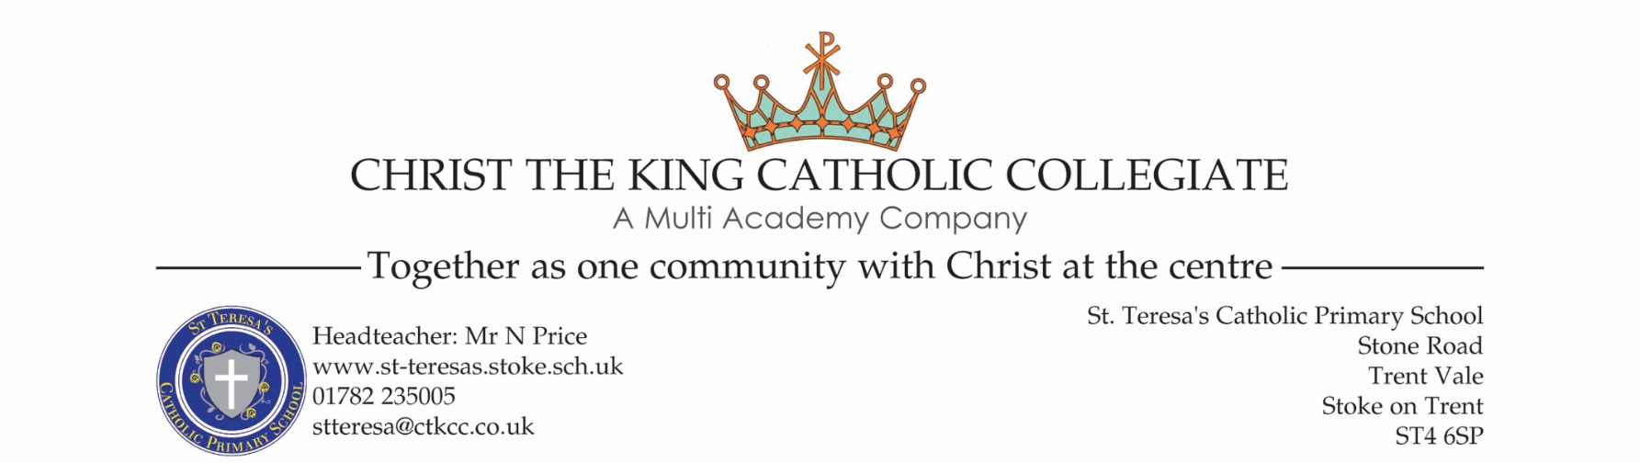

Dear parents
Following the government’s decision to close schools from today our staff have been working hard to get a system in place which will allow your children to access work from home. The link below will take you to an online folder where you will be able to access and download work by year group.
https://ctkccollegiate.sharepoint.com/:f:/s/STT_HomeWorkFiles/Ev-RsdUUh-5Eq1NuSl1n28kB8bW7aaC2ufC2VeUntytpHg?e=UJ1Gvi
If you have any issues with the home work you can email your child’s class teacher at STT_HomeWorkFiles@CTKCC.co.uk. This is a generic email address so you will need to put your child’s class and full name (i.e. Class 5/6 Joe Bloggs) in the subject line to make sure that their teacher can easily identify their emails. Please note that teachers will not be able to set individual homework tasks and will not respond to emails requesting this. The attached email address is only to be used if there are any issues with the homework that has already been uploaded to the folder.
At St Teresa’s we are determined to ensure that our pupils are provided with all of the resources that they need during the school closures so that the impact on their education is minimal. Our teachers will continue to upload work regularly but we need you to work in partnership with us to ensure that education remains a key focus. We fully understand the impact of the school closures on parents who will have the difficult task of juggling work, childcare and education and very much appreciate your support on this matter.
I would like to thank all our children, staff and parents during this difficult time. We have a very special school at St Teresa’s with a wonderful supporting Catholic community. Please take care and keep our families in your prayers.
Kind regards
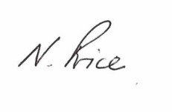
Nathan Price

